Kilbeggan (KBNB)
Wednesday 1 April 2026
10:31

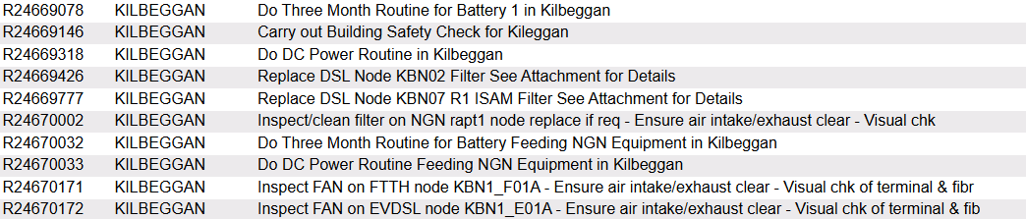

Low Voltage: NO Alarms visible to SMC
High Temperature alarm: NO Alarms visible to SMC
Low Voltage and High-Temperature alarms are NOT visible to SMC
High Battery Temperature alarm on Power One not visible to SMC

Please clean/replace filter on Nokia KBN-MSAN.

Do Three Month Routine for Battery 1 in Kilbeggan

Overall voltage: 54.24
Cell 1 - 13.49
Cell2 -13.57
Cell 3 - 13.57
Cell 4 - 13.59

Do Three Month Routine for Battery Feeding NGN Equipment in Kilbeggan

Overall: 54.11
13.46
13.51
13.57
13.54

Do DC Power Routine in Kilbeggan

Rectifiers: 6
DC Load: 18.5 A
Boost Voltage: 54.0
Float Voltage: 54.64

Low Voltage: 47V
High Temperature: 30 °C

Low Voltage and High Temperature alarms were tested, but only Low Voltage was detected.

Do DC Power Routine Feeding NGN Equipment in Kilbeggan

Rectifiers: 5
DC Load: 21 A
Boost Voltage: 54.5
Float Voltage: 54.2

Low Voltage: 47V
High Temperature: 30 ° C

Low Voltage and High-Temperature alarms are not visible to SMC.

